**Week 4 – Homework Exercise 1**

The Human Resources team has suggested that employees who have been with the company longer and those who have generated higher profits should be promoted.   
  
The team has asked you to identify the companies and job titles where they should begin promotions.

1. **Analyzing Data**
   1. Open the browser and sign in to Visual Analytics using your student credentials.
   2. Open the **VA1- Practice3.4a** report from the **SAS Content** ⇨ **Courses** ⇨ **YVA185** ⇨ **Basics** ⇨ **Practices (HR)** folder. Ensure you are in the editing report view mode.
   3. On Page 5, create a treemap by assigning the following data items to the specified roles:

|  |  |
| --- | --- |
| **Tile** | **Company** |
| **Size** | **Years of Service** |
| **Color** | **Average Profit** |
| **Data tip values** | **Add Number of Employees** |

The treemap should resemble the following:

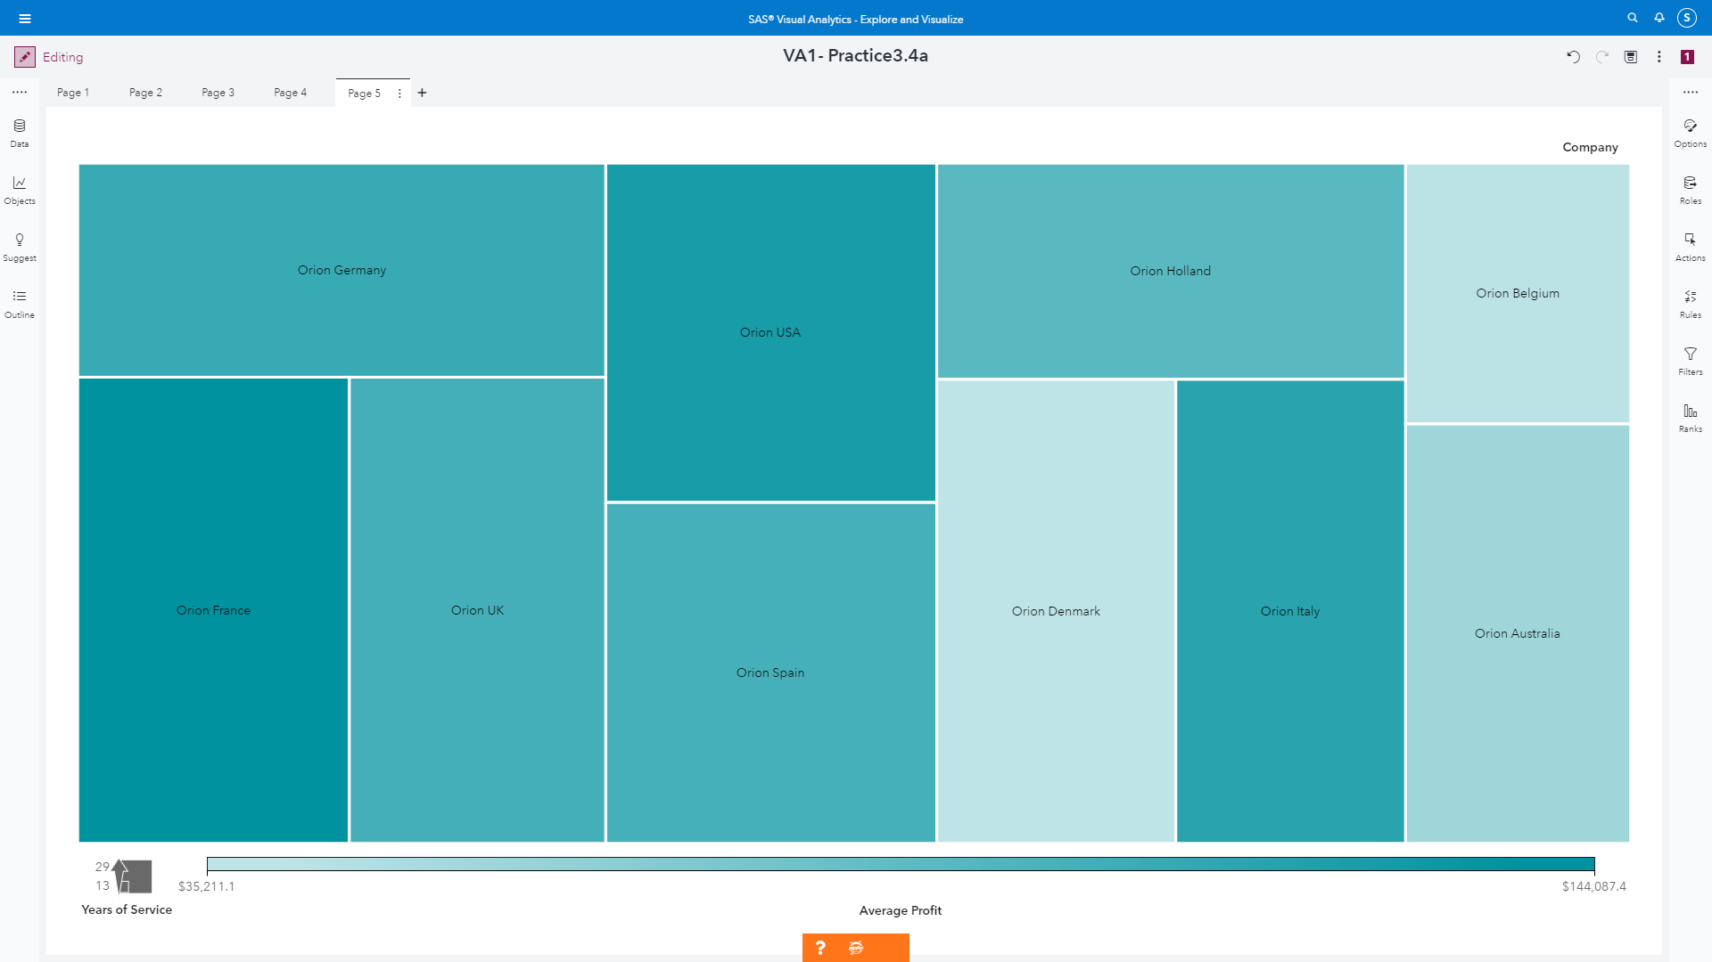

* 1. Create a new hierarchy (**Employee Hierarchy**) that contains the following categories:

**Company**

**Job Title**

* 1. In the treemap, specify **Employee Hierarchy** for the Tile role and navigate through the hierarchy to answer the following questions:

Which two companies have the highest average profit generated (one possible criterion for promotion)?

**Answer**: Orion France ($144,087.39) and Orion USA ($130,011.94)

For these two companies, which job titles would you recommend for promotion (based on average years of service and average profit generated)? Assume Sales Rep IV. Is the highest level an employee can get to (meaning they cannot be promoted higher).

**Answer**: I would say Orion France because Orion France has the longest years of service and the highest Average Profit only with 4 employees compared with Orion USA.

* 1. Save the report.
  2. Sign out of Visual Analytics.

End of Exercise

**Week 4 – Homework Exercise 2**

To complete the analysis, your manager has asked that you analyze the relationship, if any, between salary, orders, profit, and years of service to determine alternate criteria for promotion.  
  
In addition, you need to determine whether there are any job title differences between employees identified for promotion based on the criteria specified by management.

1. **Adding Data Analysis**
   1. Open the browser and sign in to Visual Analytics using your student credentials.
   2. Open the **VA1- Practice3.4b** report from the **SAS Content** ⇨ **Courses** ⇨ **YVA185** ⇨ **Basics** ⇨ **Practices (HR)** folder. Ensure you are in the editing report view mode.
   3. On Page 6, create a correlation matrix by assigning the following data items to the specified roles:

|  |  |
| --- | --- |
| **Measures** | **Annual Salary**  **Total Orders**  **Total Profit**  **Years of Service** |

The correlation matrix should resemble the following:

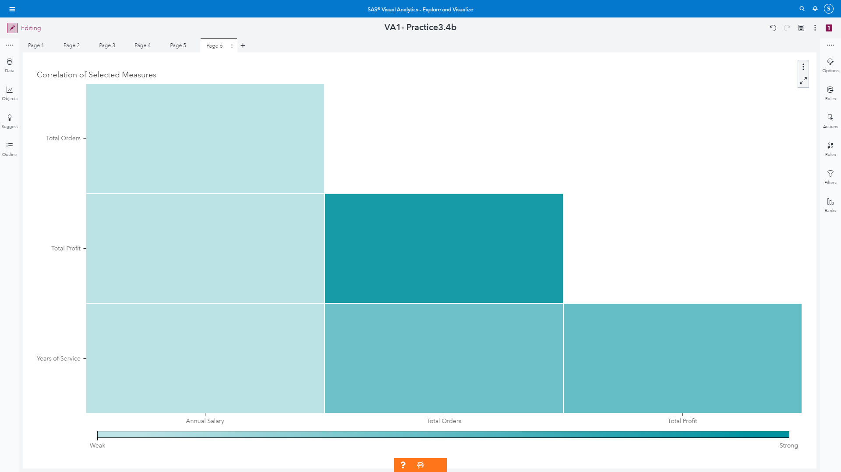

* 1. Answer the following question:

During a management meeting, it was mentioned that total orders might be a better criterion for promotion than profit generated. Do you agree?

**Answer**: I partially agree with it. Total orders and total profit’s correlation is 0.8783 which is very high value. Therefore, I think, it is not matter between total orders and total profit.

* 1. Create a scatter plot, on the right of the correlation matrix, by assigning the following data items to the specified roles:

|  |  |
| --- | --- |
| **Measures** | **Total Profit**  **Years of Service** |
| **Color** | **Job Title** |

The scatter plot should resemble the following:

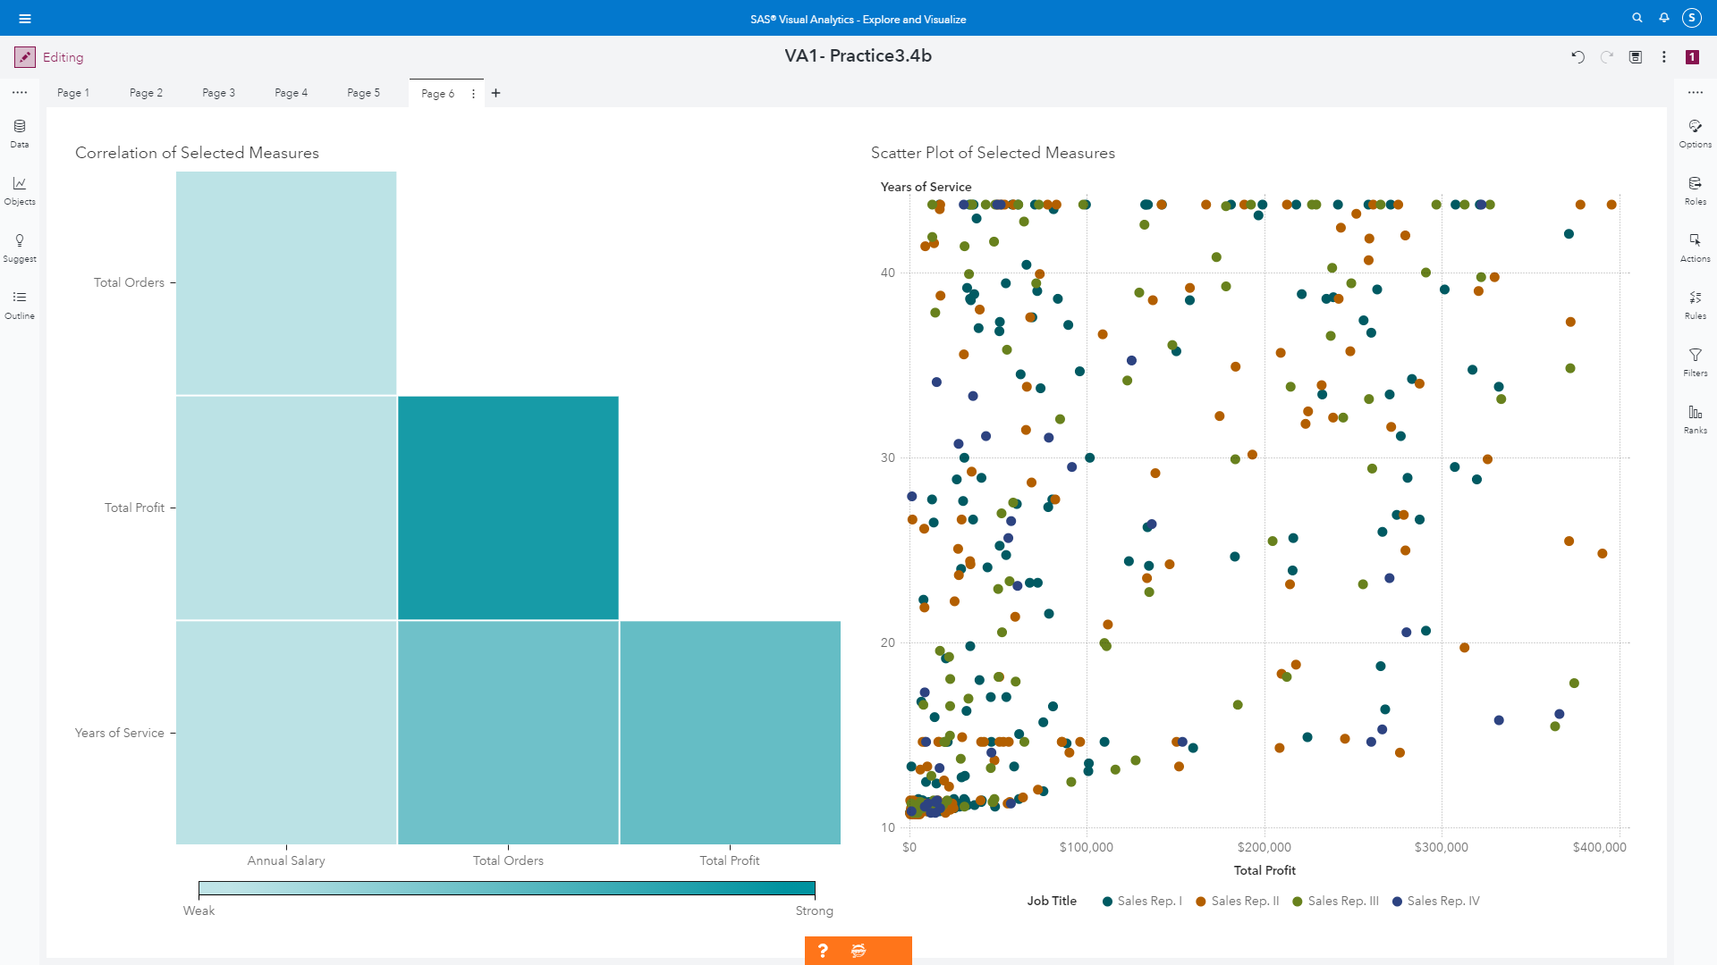

* 1. Answer the following question:

Using years of service and profit generated as promotion criteria, do you notice any differences between job titles?

**Answer**: One of Sales Rep. II ranked the most total profit and the longest years of service. Also, people who had the largest profit, they are mostly fro0m Sales Rep II. For example, one person with $395,552.03 with 44 years, and another person with $ 390,366.78 with 25 years were from Sales Rep II.

Save the report.

* 1. Sign out of Visual Analytics.

End of Exercise

**Week 4 – Homework Exercise 3**

The California Highway Patrol (CHP) has asked for a forecast of injuries from motor vehicle accidents for the next two years.  
  
We have two tables that contain information about the number of injuries, drivers, and vehicles, and a tourism index for California. One table has information for the 1990s and the other has information for the 2000s. We need to append these tables to create a data set for forecasting.

1. **Creating a Forecasting Data Source**
   1. Open the browser and sign into SAS using your student credentials.
   2. Open the **VA2-Practice3.1 plan in the SAS Content ⇨ Courses ⇨ YVA285 ⇨ Advanced ⇨ Practices** folder.
   3. View the source table properties and answer the following question:

How many columns are in the source table?

**Answer: There is 9 columns**

* 1. Append the **MVAINJURIES00** data source to the source table (**MVAINJURIES90**).

**Note:** The **MVAINJURIES00** data source is defined for the Public CAS server but is not currently loaded.

* 1. Answer the following question:

How many columns are in the **MVAINJURIES00** table?

**Answer: 9 columns**

* 1. Add a new column (**DVRatio**) to the result table that computes the ratio of **Drivers** to **Vehicles**.

**Note:** Make sure that you change the type and label of the new column as necessary.

**Note:** The resulting table should have 10 columns and 202 rows of data.

* 1. Save the plan.
  2. Sign out of Data Studio.

**Week 4 – Homework Exercise 4**

The California Highway Patrol (CHP) has asked for a forecast of injuries from motor vehicle accidents for the next two years.  
  
They would like to see how tourism or the driver-to-vehicle ratio, or both, will improve the forecast. Then they would like to see how a constant increase in the underlying factor will impact the forecast of injuries.

1. **Analyzing a Forecasting Data Source**
   1. Open the browser and sign in to SAS Visual Analytics using your student credentials.
   2. Open the **VA2-Practice3.2 report in the SAS Content** ⇨ **Courses** ⇨ **YVA285** ⇨ **Advanced** ⇨ **Practices** folder. Ensure you are in the editing report view mode.
   3. Create a forecast by assigning the following data items to the specified roles:

|  |  |
| --- | --- |
| **Time axis** | **Date** |
| **Measure** | **Injuries from Motor Vehicle Accidents** |

* 1. View details about the forecast and answer the following question:

Which algorithm is selected for the forecast?

**Answer: Algorithm was Seasonal Exponential Smoothing**

* 1. Modify options for the forecasting object to change the forecast horizon **to two years**.
  2. Add the following measures to the Underlying factors role in the forecast:

**Tourism Index (Difference from previous period)**

**DV Ratio**

Which measures, if any, were selected as underlying factors and applied to the forecast?

**Answer: Tourism Index (Difference from previous period)**

Which algorithm is now selected for the forecast?

**Answer: ARIMA : Tourism Index (Difference from previous period) ~ P = 3 NOINT**

* 1. Perform scenario analysis on the forecast by increasing the underlying factor by a constant value of 10.

How does increasing the underlying factor impact the forecast?

**Answer: When increase of tourism index, it will increase the injuries from motor vehicle accidents.**

* 1. Save the report.
  2. Sign out of Visual Analytics.